Applecross Senior High School

Western Australian Certificate of Education
Semester One Examination, 2017

Question/Answer Booklet
MATHEMATICS:

____
96
SPECIALIST
UNIT 1

Section Two:
Calculator- assumed Score for this booklet

Student’s Name: _______________________________________
As shown on your exam timetable.

Student’s Teacher Ms Coffey Ms Waddell
(Circle your teacher’s name.)

Time allowed for this section
Reading time before commencing work: ten minutes
Working time for this section: one hundred minutes

Materials required/recommended for this section
To be provided by the supervisor
This question /Answer Booklet
Formula Sheet (retained from Section One)

To be provided by the candidate
Standard Items: pens (blue/black preferred), pencils (including coloured), sharpener,
correction fluid/tape, eraser, ruler, highlighters.
Special items: drawing instruments, templates, notes on two unfolded sheets of A4 paper,
and up to three calculators approved for use in the WACE examinations.

Important note to candidates
No other items may be taken into the examination room. It is your responsibility to ensure
that you do not have any unauthorized notes or other items of a non-personal nature in the
examination room. If you have any unauthorized material with you, hand it to the supervisor
before reading any further.

Section | Number of questions available | Number of questions to be answered |  | Working time (minutes) | Marks available | Percentage of exam
Section One:  Calculator-free | 6 | 6 |  | 50 | 52 | 35
Section Two:  Calculator-assumed | 12 | 12 |  | 100 | 96 | 65
 |  |  | Total |  | 148 | 100

Instructions to candidates

- The rules for the conduct of examinations are detailed in the School Examination Rules provided with your exam timetable. Sitting this examination implies that you agree to abide by these rules.

- Write your answers in this Question/Answer Booklet.

- You must be careful to confine your responses to the specific questions asked and to follow any instructions that are specific to a particular question.

- Spare pages are included at the end of this booklet. They can be used for planning your responses and/or as additional space if required to continue an answer.
- Planning: If you use the spare pages for planning, indicate this clearly at the top of the page.
- Continuing an answer: If you need to use the space to continue an answer, indicate in the original answer space where the answer is continued, i.e. give the page number. Fill in the number of the question(s) that you are continuing to answer at the top of the page.

- Show all your working clearly. Your working should be in sufficient detail to allow your answers to be checked readily and for marks to be awarded for reasoning. Incorrect answers given without supporting reasoning cannot be allocated any marks. For any question or part question worth more than two marks, valid working or justification is required to receive full marks. If you repeat an answer to any question, ensure that you cancel the answer you do not wish to have marked.

- It is recommended that you do not use pencil, except in diagrams.

- The formula sheet and your notes are not to be handed in with your Question/Answer Booklet.

Section Two: Calculator-assumed 65% (96 Marks)
This section has twelve (12) questions. Answer all questions. Write your answers in the spaces provided.

Working time: 100 minutes.

Question 7 (6 marks)
A music playlist contains nine different tracks, including one called First Night and another called Last Night. Each track is three minutes long.

(a) A shuffle feature randomly arranges the nine tracks. Determine the number of all possible arrangements that

(i) start with First Night. (1 mark)

(ii) start with First Night and end with Last Night. (1 mark)

(iii) start with First Night or end with Last Night. (2 marks)

(b) Determine the number of selections of different tracks from the playlist that do not include First Night and Last Night and have a total playtime of 15 minutes. (2 marks)

Question 8 (5 marks)
In the diagram below, $AD$ and $BE$ are diameters of the circle with centre $O$, $C$ lies on the circumference and $∠COD=28°$.

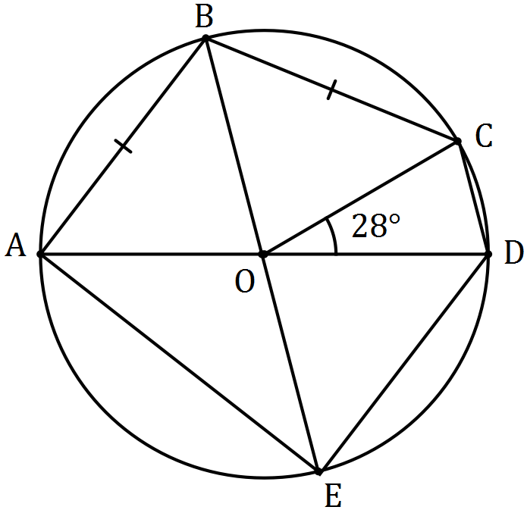

Determine the sizes of the following angles.

(a) $∠AOB$. (2 marks)

(b) $∠AEB$. (1 mark)

(c) $∠ADE$. (2 marks)

Question 9 (8 marks)
Two tugs pull an offshore drilling rig. The first tug applies a force of 5 500 N in direction 122° and the second tug applies a force of 6 000 N in direction 088°.

(a) Show that the resultant force applied by the two tugs has magnitude close to 11 000 N, and determine the angle that the resultant force makes with the direction of the force applied by the first tug boat. (5 marks)

(b) The second tug boat is asked to decrease the magnitude of the force it applies to reduce the resultant force to 9 000 N. Determine the percentage decrease required. (3 marks)

Question 10 (8 marks)
(a) The points P and Q have position vectors $5i-2j$ and $-4i+5j$ respectively.
The point K is such that PK = $-$4QK. Find the position vector of K. (3 marks)

(b) Given that $u=〈 -4,16 〉$ and $\left|v\right|=100,$ find $v$ if $u+v$ is to be in the same direction as
vector $〈2,2〉$. (5 marks)

Question 11 (8 marks)
(a) In the diagram, , $B$, $C$ and $D$ lie on the circumference of circle with centre $O$. Given that $∠ADC=67°$, $∠BCO=63°$ and $∠DCO=23°$ determine the values of $a$, $b$ and $c$. (3 marks)

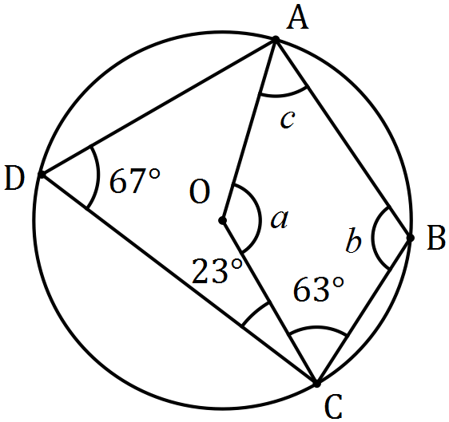

(b) In the diagram below, points $B$, $C$ and $D$ lie on the circumference of circle centre $O$ and $AB$ and $AD$ are tangents to the circle.
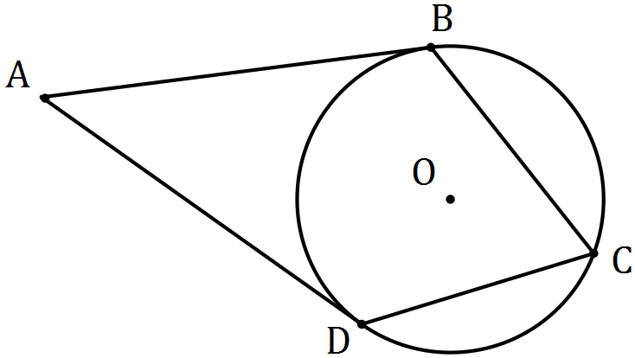

(i) Prove that $ABOD$ is a cyclic quadrilateral. (3 marks)

(ii) Determine the size of $∠BAD$ if the size of $∠BCD=78°$. (2 marks)

Question 12 (8 marks)
A seaplane with a cruising speed of 250 kmh⁻¹ is required to fly to a location 355 km away on a bearing of 305°. A wind of 36 kmh⁻¹ is blowing from bearing 020°.

(a) Sketch a diagram to show this information. (2 marks)

(b) Determine the bearing that the seaplane should steer. (3 marks)

(c) Determine the flight time, in hours and minutes. (3 marks)

Question 13 (9 marks)
Seven teams from WA, six teams from SA and five teams from NT apply for eight available places in a league competition. The league is run so that every team plays every other team exactly once and no game ends in a tie.

(a) The organisers decide that there must be at least four teams from WA and an equal number of teams from SA and NT. Determine the total number of ways in which the organisers can select the eight teams for the league. (3 marks)

Assume the eight teams have already been chosen.

(b) Determine the number of games that will be played in the league and hence the number of schedules possible for the first three games. (3 marks)

(c) Use the pigeon hole principle to show that if no team loses all its games, then at least two teams finish the competition with the same number of wins. (3 marks)

Question 14 (8 marks)
Three vectors are given by $a=3i-4j$, $b=-3i+1.5j$ and $c=-2i+yj$, where $y$ is a constant.

(a) Determine the vector projection of $b$ on $a$. (3 marks)

(b) Determine the value(s) of $y$ if

(i) $a$ and $c$ are perpendicular. (2 marks)

(ii) the angle between the directions of $b$ and $c$ is 45°. (3 marks)

Question 15 (9 marks)
(a) The work done, in joules, by a force of $F$ Newtons in changing the displacement of an object by $s$ metres, is given by the scalar product of $F$ and $s$.

(i) A force of 250 N acting due south moves an object 4.3 m in a south-westerly direction. Determine the work done. (2 marks)

(ii) Another force of 155 N does 269 joules of work in moving an object 190 cm. Determine the angle between the force and the direction of movement. (2 marks)

(b) A triangle is formed by three non-zero vectors $a$, $b$ and $c$, so that $c=a-b$, and $θ$ is the angle between $a$ and $b$.

(i) Sketch the triangle. (1 mark)

(ii) Explain why $c∙c={\left|c\right|}^{2}$. (1 mark)

(iii) Use $c∙c=\left(a-b\right)∙\left(a-b\right)$ to deduce the cosine rule. (3 marks)

Question 16 (10 marks)
In the diagram below, $POT$ is a diameter of circle with centre $O$, $QP$ is a tangent to the circle at $P$, $QR$ is a tangent to the circle at $R$ and $PT$ is extended to meet $QR$ extended at $S$. You may want to let $∠OTR=θ$.

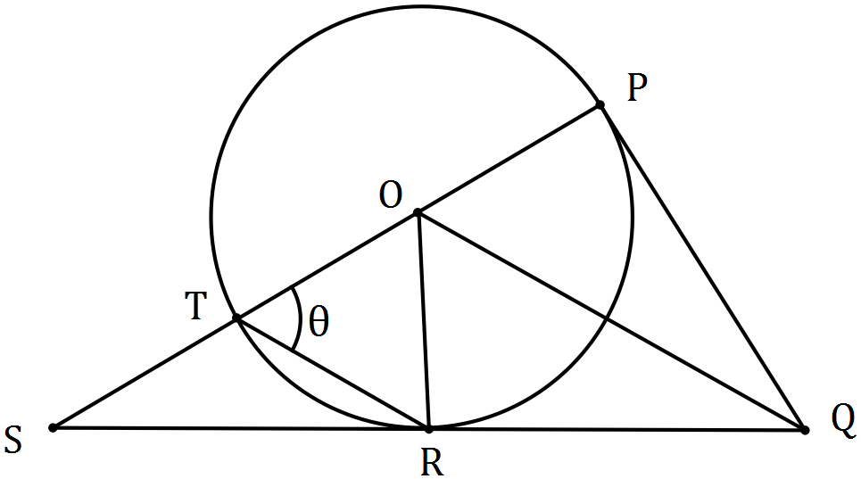

(a) Prove that $ΔOPQ$ is congruent to $ΔORQ$. (3 marks)

(b) Prove that $OQ$ is parallel to $TR$. (4 marks)

(c) If $TR=TS$, deduce that $ΔOTR$ is equilateral. (3 marks)

Question 17 (11 marks)
A small boat that can maintain a steady speed of 5 ms⁻¹ is to cross a river from $A$ to $B$, where
$\vec{AB}=\left(35i-105j\right) \text{m}$.

A current of $\left(-i-2j\right) {\text{ms}}^{-1}$ flows in the river.

The velocity vector that the pilot of the small boat must set to travel from $A$ to $B$ is $ai+bj$, where $a$ and $b$ are constants.

(a) Explain why $t\left(a-1\right)=35$ and $t\left(b-2\right)=-105$, where $t$ is a constant. (3 marks)

(b) Eliminate $t$ from the equations in (a) and hence express $b$ in terms of $a$, simplifying your expression. (3 marks)

(c) Explain why $a^{2}+b^{2}=25$. (1 mark)

(d) Use your equations from (b) and (c) to determine the values of $a$ and $b$. (3 marks)

(e) Determine the time that the small boat will take to travel from $A$ to $B$. (1 mark)

Question 18 (6 marks)
Let $g\left(x\right)=x^{2}-8x+19, x∈Z$.

(a) Use an example to show that when $x$ is odd, $g\left(x\right)$ is even. (1 mark)

(b) Write the contrapositive of "if $g(x)$ is an even integer, then $x$ is an odd integer". (1 mark)

Any even integer $m$ can be expressed in the form $m=2a$, where $a∈Z$. Similarly, any odd integer $n$ can be expressed in the form $n=2a+1$.

(c) Simplify $g(2a)$. (1 mark)

(d) Express $g(2a)$ in a form that clearly shows it is an odd integer. (1 mark)

(e) Use your answers above to prove that if $g(x)$ is even, then $x$ is odd. (2 marks)

Additional working space.

Question Number:_________

Additional working space.

Question Number: _________

